**A PRELIMENERY REPORT ON**

**CROWDKINDNESS**

SUBMITTED TO THE VISHWAKARMA INSTITUTE OF INFORMATION TECHNOLOGY, PUNE

IN THE PARTIAL FULFILLMENT OF THE REQUIREMENTS

FOR THE AWARD OF THE DEGREE

OF

**BACHELOR OF TECHNOLOGY (COMPUTER ENGINEERING)**

##### SUBMITTED BY

**TEJAS PATEL** **22110786**

**VIGHNESH KANDALGAONKAR 22220086**

**SUYASH GADHAVE 22220085**

**DWARKESH DESHMUKH 22220117**

**SUSHANT GADGE 22220233**



## DEPARTMENT OF COMPUTER ENGINEERING

**BRACT’S**

**VISHWAKARMA INSTITUTE OF INFORMATION TECHNOLOGY**

SURVEY NO. 3/4, KONDHWA (BUDRUK), PUNE – 411048, MAHARASHTRA (INDIA).

|  |  |  |  |  |  |
| --- | --- | --- | --- | --- | --- |
| **Sr. No.** | | | | **Title of Chapter** | **Page No.** |
| **01** | | | | **Introduction** |  |
|  | 1.1 | | | Overview |  |
|  | 1.2 | | | Motivation |  |
|  | 1.3 | | | Problem Definition and Objectives |  |
|  | 1.4 | | | Project Scope & Limitations |  |
| **02** | | | | Literature Survey |  |
| **03** | | | | System Design |  |
|  | | 3.1 | | System Architecture |  |
| **04** | | | | Project Implementation |  |
|  | | | 4.1 | Overview of Project Modules |  |
|  | | | 4.2 | Tools and Technologies Used |  |
| **05** | | | | Results |  |
|  | | | 5.1 | Outcomes |  |
|  | | | 5.2 | Screen Shots |  |
| **06** | | | | Conclusions |  |
|  | | 6.1 | | Future Work |  |
|  | | 6.2 | | Applications |  |
|  | | | | **References**  [1] R. A. P. B. M. Jayasundara, “Crowd Funded Donation Management System,” 2023.  [2] S. Tunçer, A. Özdede, and C. Karakuzu, “Transparent Donation Management with Smart Contract-Based Blockchain.” [Online]. Available: https://orcid.org/0000-0001-6672-3605  [3] R. Meersman, “Models of Charity Donations and Project Funding in Social Networks *,” 2009. |  |

**01. Introduction**

**1.1 Overview**

CrowdKindness is a crowdfunding platform that enables individuals, groups, organizations to raise funds for a wide range of personal, charitable, and community- oriented causes. This platform provides a digital space where donors and fundraisers can connect, collaborate, and contribute to meaningful causes, ranging from personal emergencies to large-scale humanitarian efforts.

Our website offers a comprehensive platform that caters to a diverse range of users, from donors looking to contribute to meaningful causes to fundraisers seeking support for their initiatives. With robust features and secure payment methods, our platform empowers users to engage in philanthropy, manage donations, and effect positive change in their communities.

**1.2 Motivation**

The motivation behind our project stems from a deep-seated belief in the transformative power of collective giving and the potential to effect positive change through technology. In today's interconnected world, we are presented with unprecedented opportunities to connect with and support causes that matter to us, yet navigating the complexities of traditional fundraising can be daunting.

Our project seeks to bridge this gap by providing a user-friendly and inclusive platform that empowers individuals and organizations to rally support for their initiatives, amplify their voices, and make a tangible impact on the causes they care about. By harnessing the reach and accessibility of the internet, we aim to democratize philanthropy and create a space where anyone, regardless of background or resources, can become a catalyst for change.

**1.3 Problem Definition and Objectives**

**Problem Statement -**

Despite the widespread availability of online fundraising platforms, many individuals and organizations still face challenges when it comes to raising funds for their initiatives. Traditional fundraising methods can be time-consuming, inefficient, and limited in reach, hindering the ability of fundraisers to connect with potential supporters and maximize their impact.

**Objectives -**

1. Streamline Fundraising Processes.
2. Expand Reach and Accessibility.
3. Enhance Donor Engagement.
4. Ensure Security and Transparency.
5. Promote Social Good.

**1.4 Project Scope and Limitations**

**Scope -**

Using this platform users can create fundraising campaigns for various purposes, including personal emergencies, medical expenses, educational pursuits, charitable projects, and community initiatives. The platform also facilitates secure donation processing through multiple payment methods, including credit/debit cards, and other online payment platforms.

Fundraisers also have access to tools for managing their campaigns, including updating campaign details, communicating with donors, and tracking fundraising progress. Robust security measures are implemented to protect user data and financial transactions, and transparency protocols ensure accountability and trustworthiness in campaign management.

**Limitations -**

While the platform aims to reach a global audience, certain geographical restrictions may apply based on legal and regulatory requirements in specific regions.The platform may also incur fees associated with payment processing, which are passed on to fundraisers or deducted from donations. These fees vary based on the payment method and may impact the total amount received by fundraisers.

While efforts are made to verify the legitimacy of campaigns, the platform cannot guarantee the accuracy or authenticity of all campaign information. Users are encouraged to exercise due diligence when contributing to campaigns. Campaigns may be subject to a review and approval process to ensure compliance with platform guidelines and policies. Delays in campaign approval may occur due to high volume or resource constraints.

The platform may also experience technical issues or downtime due to maintenance, upgrades, or unforeseen circumstances. Efforts are made to minimize disruptions and resolve issues promptly, but users should be aware of the potential for temporary interruptions in service.

**02. Literature Survey**

[1], [2], [3] In contemporary society, charity stands as a cornerstone of compassion, embodying the ethos of a strong individual extending aid to those in need. Despite its importance, both Non-Governmental Organizations (NGOs) and individuals encounter hurdles in sourcing funds amidst economic downturns and inflationary pressures. These challenges underscore the critical need for innovative approaches to fundraising and donor engagement.

Addressing the imperative for trust in philanthropic endeavors, the literature emphasizes the significance of donor confidence in ensuring the efficacy of their contributions. Instances of fraudulent activities within charitable institutions can erode public trust, highlighting the necessity for transparent and accountable fundraising mechanisms.

In response to these challenges, the emergence of crowd-funded donation management systems like "Charity" offers a promising avenue for revitalizing philanthropic efforts. Inspired by successful models such as Google's local guide program, these platforms seek to foster social engagement while enhancing transparency and authenticity in fundraising campaigns.

Central to the efficacy of such systems is the seamless integration of donor participation, from campaign creation to contribution. By empowering authorized individuals to verify campaign authenticity and facilitating social media sharing, these platforms not only raise awareness but also cultivate a sense of community among donors.

Moreover, the literature underscores the importance of incorporating features such as performance, security, reliability, and maintainability in the design and implementation of donation management systems. Clear dashboards and comprehensive reports further enhance user experience, facilitating informed decision-making and fostering continued donor engagement.

Moving forward, research in this field aims to explore innovative approaches to online fundraising, including the development of novel donation models and strategies for reporting project outcomes. By leveraging the potential of web-based platforms, scholars seek to harness the collective goodwill of individuals and organizations in support of meaningful social and charitable endeavors.

**03. System Design**

The donation website utilizes the MERN stack, comprising MongoDB, Express.js, React.js, and Node.js, for its architecture. On the front end, React.js powers an intuitive user interface with components for campaign creation, donation processing, and user dashboards. The backend, built with Node.js and Express.js, handles client-server communication, authentication, and business logic, while MongoDB serves as the database for storing user profiles, campaigns, and transactions. Payment gateways such as PayPal or Stripe are integrated for secure donation processing. The system is hosted on a cloud platform for scalability and reliability, with Docker containers ensuring deployment consistency. Security measures include HTTPS encryption, JWT-based authentication, and data encryption. Monitoring tools like Prometheus and Grafana provide insights into system performance, while centralized logging facilitates auditing and troubleshooting.

**3.1 System Architecture**

**1. Client Side**

* UI (React.js) : Renders intuitive UI for navigation and donation process.
* Components : Campaign creation, donation process, social sharing, and user dashboard.
* State Management : Utilizes Redux or Context API for managing application state.

**2. Server Side**

* Node.js with Express.js : Provides backend logic for client-server communication.
* API Endpoints : Handles user authentication, campaign management, and donation processing.
* Middleware : Implements authentication and error handling middleware.

**3. Payment Gateways**

* Integration Layer : Incorporates payment gateways for secure online transactions.
* Processing : Utilizes payment gateway APIs to process donations securely.
* Confirmation : Provides users with confirmation of successful donations.

**4. Database Layer**

* MongoDB : Stores user profiles, campaigns, and transactions with efficient querying.

**5. Security**

* HTTPS : Secures communication with SSL/TLS encryption.
* Authentication : JWT-based authentication and authorization.
* Data Encryption : Encrypts sensitive data at rest and in transit.

**04. Implementation**

**4.1 Modules**

**1. User Authentication**

User authentication is a critical module within the donation website, facilitating secure access to the platform's features. This module enables users to register and create accounts, providing them with unique credentials for subsequent logins. Implemented using JWT-based authentication, the module ensures that user sessions are securely managed and authenticated with each interaction. Through robust encryption techniques and secure token handling, user authentication safeguards sensitive user information and prevents unauthorized access to user accounts. By integrating best practices in authentication, such as password hashing and token expiration policies, the module enhances the overall security posture of the platform, instilling trust and confidence among users.

**2. Campaign Management**

The campaign management module serves as the backbone of the donation website, empowering users to create, customize, and manage fundraising campaigns effortlessly. Through an intuitive interface, users can define campaign details such as goals, descriptions, and timelines, tailoring each campaign to specific causes or initiatives. This module facilitates seamless collaboration and engagement among campaign organizers and donors, providing a centralized platform for promoting charitable endeavors. With features for editing and deleting campaigns as needed, the module ensures flexibility and adaptability in campaign management, allowing users to adjust strategies and goals based on real-time feedback and performance metrics.

**3. Donation Processing:**

At the heart of the donation website lies the donation processing module, which facilitates secure and efficient handling of online transactions. Integrated with reputable payment gateways, this module enables users to make donations securely using various payment methods, including credit cards, debit cards, and digital wallets. Leveraging encryption and tokenization techniques, the module ensures the confidentiality and integrity of sensitive financial data, safeguarding against fraud and unauthorized access. Real-time processing capabilities enable immediate confirmation of donations, providing donors with peace of mind and transparency throughout the transaction process.

**4.2 Tools and Technologies -**

* **FRONTEND :** React.js, Redux Toolkit, Styled Components
* **BACKEND** : Node.js, Express.js, JWT Token
* **DATABASE :** MongoDB
* **PAYMENT GATEWAY -** RazorPay

**05. Results**

**5.1 Outcome**

The integration of these tools and technologies culminated in a robust and user-friendly donation website. Users can seamlessly navigate intuitive interfaces crafted with React.js and Material UI, while Redux Toolkit ensures efficient state management for a smooth user experience. The backend, powered by Node.js and Express.js, securely handles requests using JWT tokens for authentication. MongoDB serves as a reliable database for storing user data and campaign details. This cohesive implementation results in a platform that facilitates charitable giving and fosters a sense of community engagement.

**5.2 Screenshots**

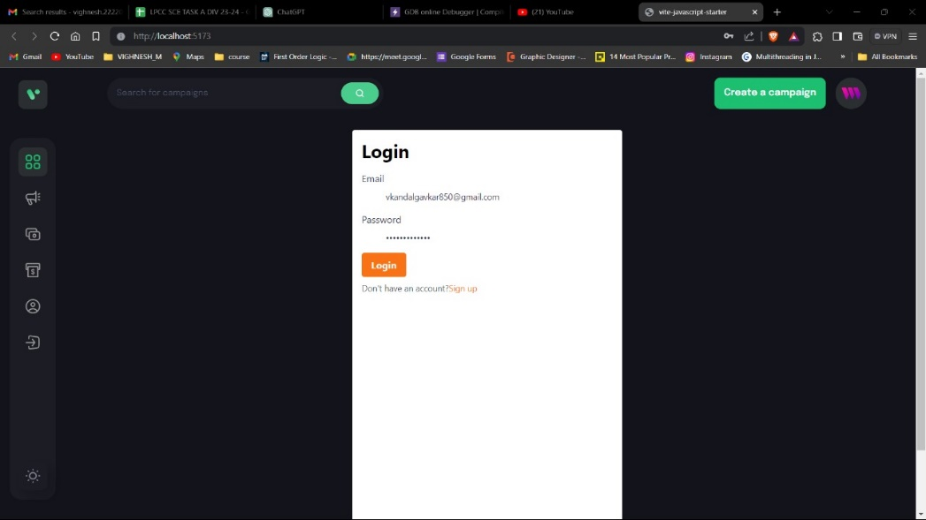

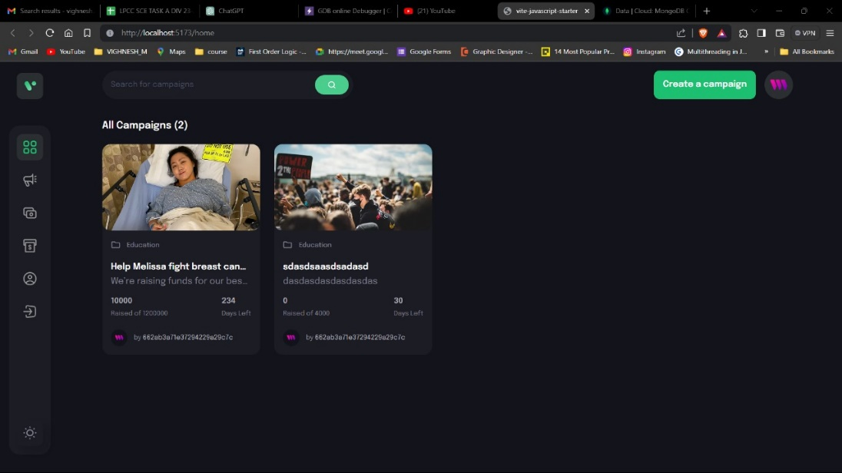

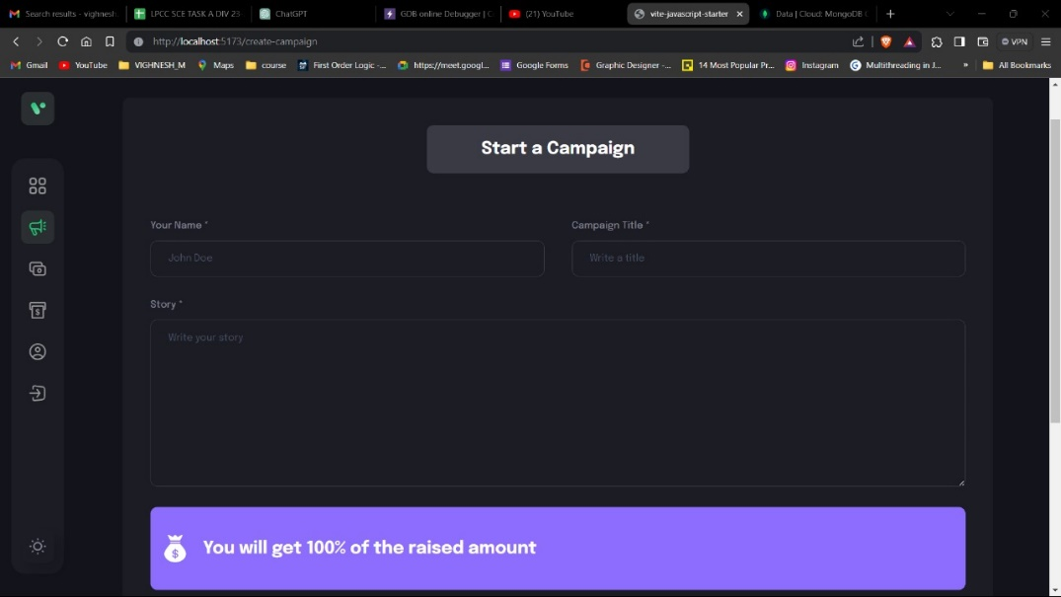

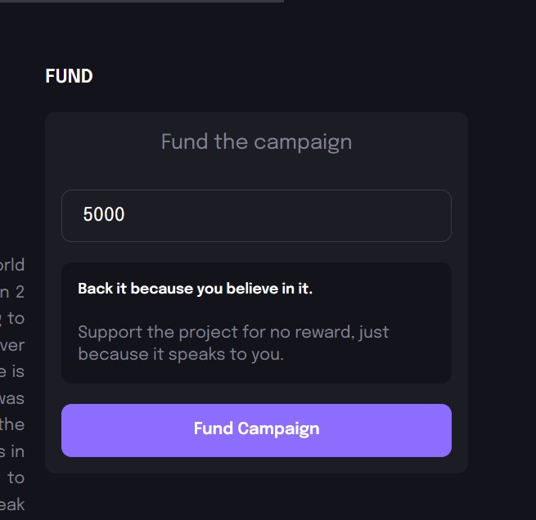

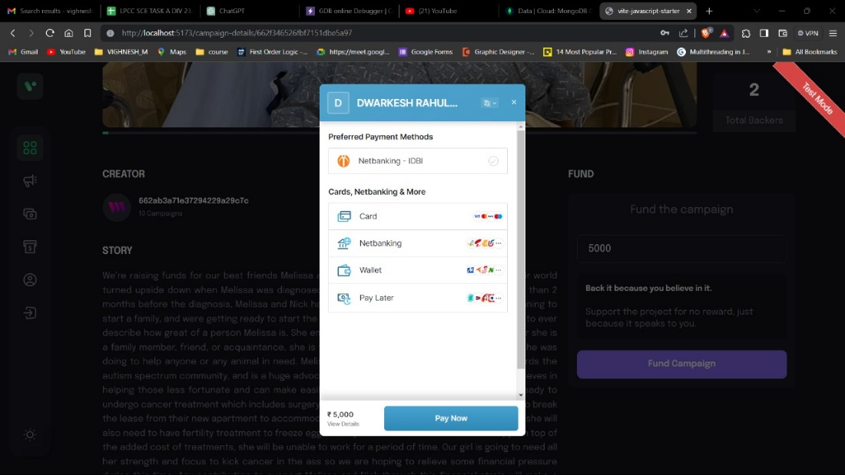

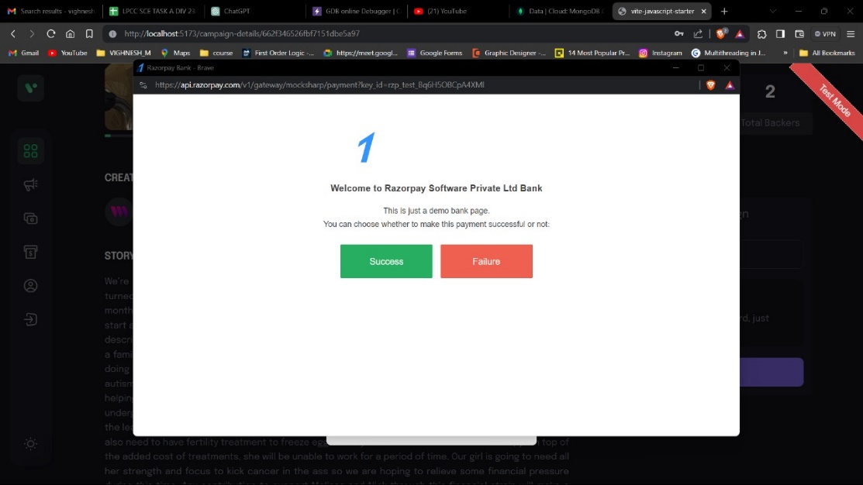

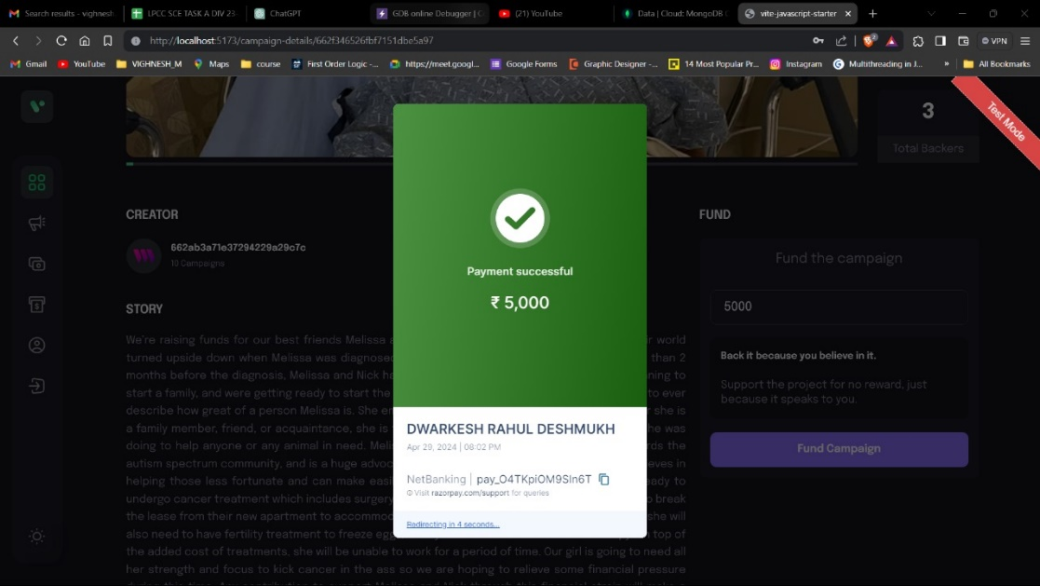

**06. Conclusions**

In conclusion, the development of the donation website has been a significant endeavor aimed at creating a platform that facilitates charitable giving and fosters community engagement. By leveraging a modern tech stack including React.js, Node.js, and MongoDB, we have successfully built a robust and user-friendly platform. The integration of tools such as Material UI and Redux Toolkit ensures a seamless user experience, while JWT token authentication enhances security. Through this project, we have not only provided users with a convenient way to contribute to charitable causes but also created a sense of community and solidarity. Moving forward, we are committed to further enhancing the platform's functionality, scalability, and accessibility to continue making a positive impact on society.

**6.1 Future Work**

Moving forward, we plan to enhance the donation website in several key areas. Improving the user experience through UI refinement and mobile optimization will be a priority, alongside expanding social integration for broader campaign promotion. Advanced analytics will provide valuable insights into user behavior and campaign effectiveness, guiding future fundraising strategies. Building a strong sense of community through forums and events, ensuring accessibility, and expanding international reach will also be key focuses. Additionally, forging partnerships with organizations and influencers will amplify the platform's impact. These efforts aim to further empower users and strengthen the platform's role in facilitating charitable giving.

**6.2 Applications**

1. Charitable Organizations: Create fundraising campaigns for disaster relief, medical expenses, education, and environmental conservation.

2. Individual Fundraisers: Advocate for personal challenges or causes, garnering support and donations from friends, family, and the public.

3. Community Groups: Organize fundraising events and campaigns for community projects, charity drives, or local initiatives.

4. Educational Institutions: Raise funds for scholarships, educational programs, extracurricular activities, and campus improvements.

5. Businesses: Participate in corporate social responsibility initiatives by supporting social causes, sustainability, or disaster relief efforts.

6. Event Organizers: Integrate fundraising campaigns into events such as marathons, festivals, or conferences to support charitable causes.

7. Individual Donors: Contribute financially or share campaigns on social media to support causes they resonate with.

8. Volunteer Groups: Raise funds for projects, outreach programs, and humanitarian missions to complement volunteer efforts.

***REFERENCES***

[1] R. A. P. B. M. Jayasundara, “Crowd Funded Donation Management System,” 2023.

[2] S. Tunçer, A. Özdede, and C. Karakuzu, “Transparent Donation Management with Smart Contract-Based Blockchain.” [Online]. Available: https://orcid.org/0000-0001-6672-3605

[3] R. Meersman, “Models of Charity Donations and Project Funding in Social Networks *,” 2009.